Lab - Manage Virtual Memory

# Christian Jay M. Putol

05/18/2023

# Introduction

In this lab, you will customize virtual memory settings.

# Recommended Equipment

* A computer with Windows installed with two or more partitions

**Note**: At least 2GB of free space is recommended on the second partition.

# Instructions

1. Save as this file to your account.

Use your name for your virtual machine.

1. Put your screenshots and answers after each step.

## Open System Properties

* + - 1. Navigate to the **Control Panel**. In the Small icons view, click **System**.
      2. In the System window, click **Advanced system settings**.
      3. In the **System Properties** window, select the **Advanced** tab and click **Settings** under the Performance heading.

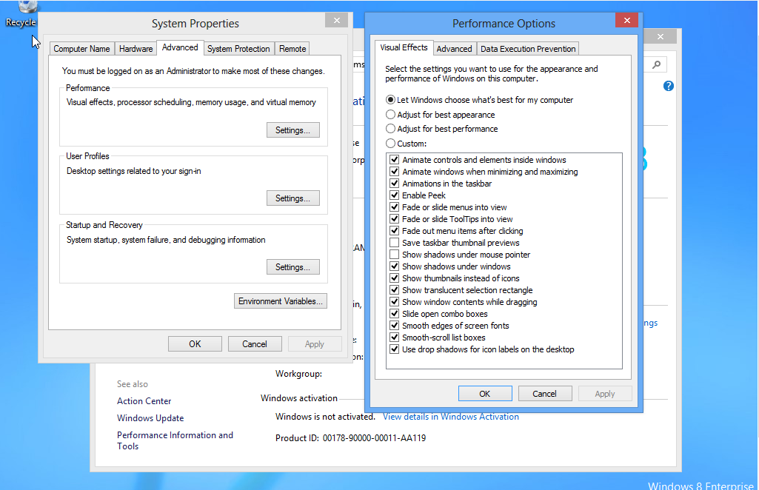

* + - 1. In the **Performance Options** window, click the **Advanced** tab.

#### Question:

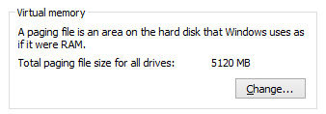

What is the current size of the virtual memory (paging file)?

* It has 5,120MB.

## Make virtual memory changes.

* + - 1. Click **Change** in the Virtual memory area to open the **Virtual Memory** window.
      2. Remove the check mark from Automatically manage paging file size for all drives.

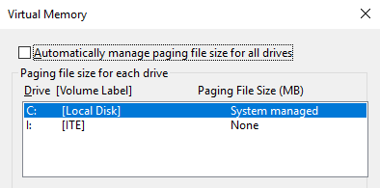

#### Question:

What Drive [Volume Label] contains the paging file?

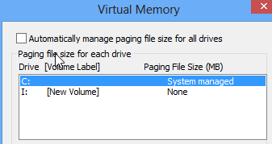

* The drive C:/
  + - 1. Choose the **I:** drive. Select the **Custom size:** radio button.

**Note**: Your drive letter and volume may be different than the example. Replace **I:** with the drive letter for your second partition on your PC.

If there is only one partition on the hard drive, use **Disk Management** to create a second partition with at least 2GB before continuing with this lab.

#### Question:

What is the recommended paging file size for all drives?

* It is recommended to have 4991MB
  + - 1. Enter a number smaller than the recommended file size in the **Initial size (MB):** field. Enter a number that is larger than the Initial size but smaller than the recommended file size in the **Maximum size (MB):** field. Click **Set**.

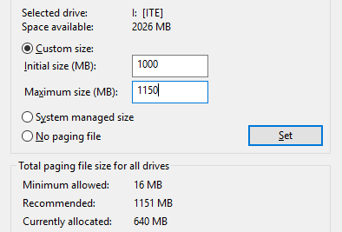

* + - 1. Select the **C:** drive. Select the **No paging file** radio button and click **Set**.

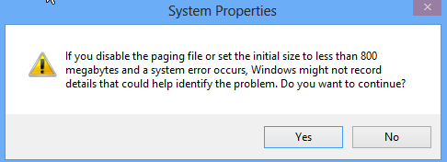

* + - 1. The System Properties warning message displays. Click **Yes** to continue.
      2. Click **OK** in the **Virtual Memory** window to accept the new virtual memory settings.
      3. Click **OK** in the Performance Options and System Properties windows.
      4. Click **Restart Now** when prompted to restart to apply the changes.

## Navigate back to the Virtual Memory window to verify changes.

* + - 1. Navigate to the **System Properties** window. (**Control Panel** **> System >Advanced system settings**). Select the **Advanced** tab and click **Settings** in the Performance area.
      2. In the **Performance Options** window, select the **Advanced** tab and click **Change**.
      3. The **Virtual Memory** window opens displaying the new paging file information. Verify your changes.

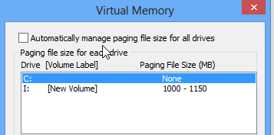

#### Question:

What Drive [Volume Label] contains the paging file?

* The drive that contains the paging file is the drive I:

## Reset the virtual memory back to the original settings.

* + - 1. Select drive **C: [Local Disk]** > click **System managed size** > click **Set**.
      2. Select **I:** > click **No paging file** > click **Set**.

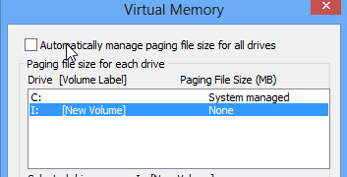

* + - 1. Check **Automatically manage paging file size for all drives**, and then click **OK**.
      2. The **System Properties** window opens informing you that a restart is required before changes will take effect. Click **OK**.

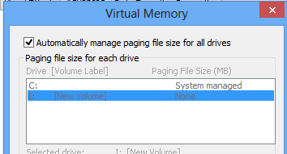

* + - 1. Click **OK** to close the **Performance Options** window. Click **OK** to close the System Properties window.
      2. The warning message displays: You must restart your computer to apply these changes. Click **Restart Now**.

# Reflection Questions

Why would you ever change the default virtual memory page file settings in Windows?

Type your answers here.

End of Document